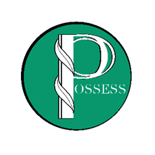

**POSSESS Meeting Agenda**

**January 25, 2023**

**10:00AM-12:30PM**

**Hybrid Meeting**

|  |  |
| --- | --- |
| Virtual Option: | In-Person Option: |
| Email invite From Microsoft Teams | The Franklin Center  50 Claiborne Avenue  Rocky Mount, VA 24151 |

**Meeting Called By:** Janet Briscoe

**Presentation(10AM):** Self-Awareness Presentation/Training by Allison Davidson, Author of

“No Excuses: Celebrate You”

**New Business:** Update from VLSSE Professional Development/Personnel Dec Mtg

Website Update/Information

30th Anniversary of POSSESS

**Committee Reports:** Professional Development- Mary Cloud

Fundraising- Denita Dixon

Membership- Ann May

Technology- Anne Marie Giannini

Networking-Carol Callaway

Sunshine- Melissia Hill

**Open Discussion:** Next meeting will be March 15th in the Eastern Region

Networking Activity- Setting up Interest Subgroups by Tasks

**Adjournment:** Janet Briscoe