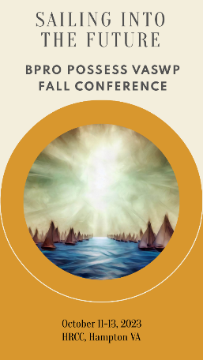**Sailing into the Future**

**2023 Fall BPRO- POSSESS -VASWP Conference**

**October 11-13, 2023 in Hampton**

|  |
| --- |
| **Tentative Workshops:** |
| * **SNAP Work Requirement Part 2** * **Medical Assistance and Immigrants** * **TANF Workforce Tool** * **SNAP Expenses** * **LTSS Patient Pay Adjustments** * **Understanding and Updating MMIS** * **Questionable Information** * **Services Panel Discussion** * **Workforce Development** * **Legislative Information** * **Improving your Softskills** * **TANF Hot Topics II** * **Child Care Policy and Updates** * **PIP Program** * **Energy Assistance and Vendor Relations** * **SNAP EBT Scams and Replacements** * **MMIS & Enrollment Medical Assistance Reporting** * **CQI** * **Kinship** * **Legislation (Services)** * **Self-Care in High Stress** * **Financial Exploitation** * **And much MUCH MORE!** |

**Wednesday, October 11, 2023**

**8:00 am Registration Begins**

**8:30 am Pre-conference workshops**

**10:00 am Break**

**10:15 am** T**im Gard, Key Note Speaker**

You won’t want to miss this!

Finding Happiness isn’t Rocket Surgery – Burn Bright, Don’t Burn Out Visit TimGard.com for more Info

**11:45 am Lunch (provided)**

**Welcome:**

**BPRO/POSSESS/VASWP Presidents**

**1:15 pm BPRO Business Meeting**

**POSSESS Business Meeting**

**VASWP Business Meeting**

**2:45 pm Break**

**3:00 pm Benefit Programs Panel**

**VASWP Panel Discussion**

**Thursday, October 12, 2023**

**8:30 am Workshops**

**10:00 am Break**

**10:15 am Workshops**

**11:45 am Lunch (provided)**

**1:15 pm Workshops**

**2:45 pm Break**

**3:00 pm Workshops**

**BPRO Business meeting**

**Friday, October 13, 2023**

**8:30 am Workshops**

**10:00 am Break**

**10:15 am Workshops**